
Name | Shahzaib Haider
Registration Number | FA23-BAI-050
Submitted To | Dr. Iftikhar Azim Niaz
Date | 26thMarch,2026
Submitted by | FA22-BAI-012
Group | 15

Software Engineering

1. AI Route Anomaly Detection (Safety Feature)
AI Justification: An ML model continuously monitors the live GPS stream against the expected OSRM route. If the deviation exceeds a learned threshold, it flags a potential safety issue.
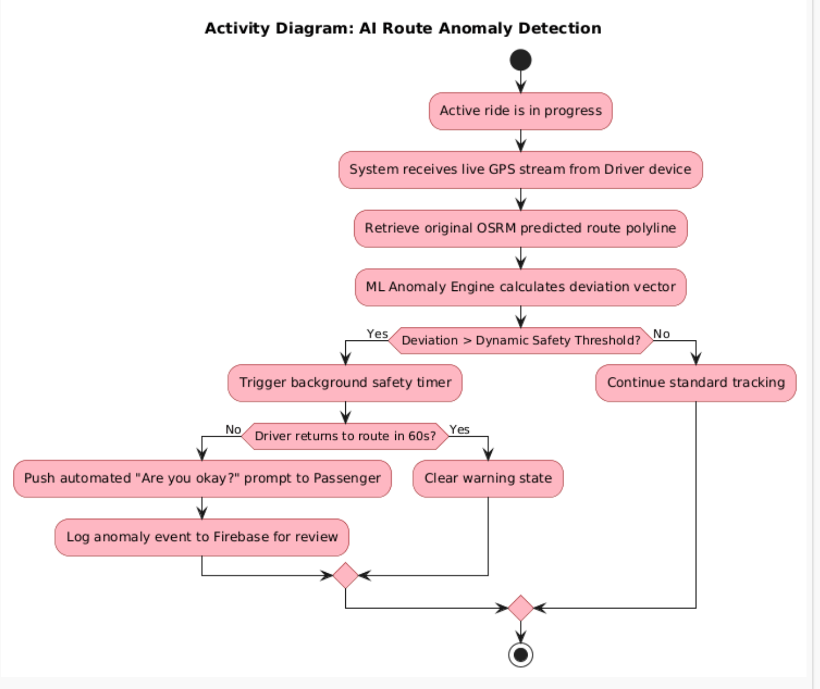

2. Predictive Demand Heatmap (Clustering)
AI Justification: Uses the K-Means clustering algorithm on historical ride data to predict where high passenger demand will be, visually guiding drivers to hot zones.
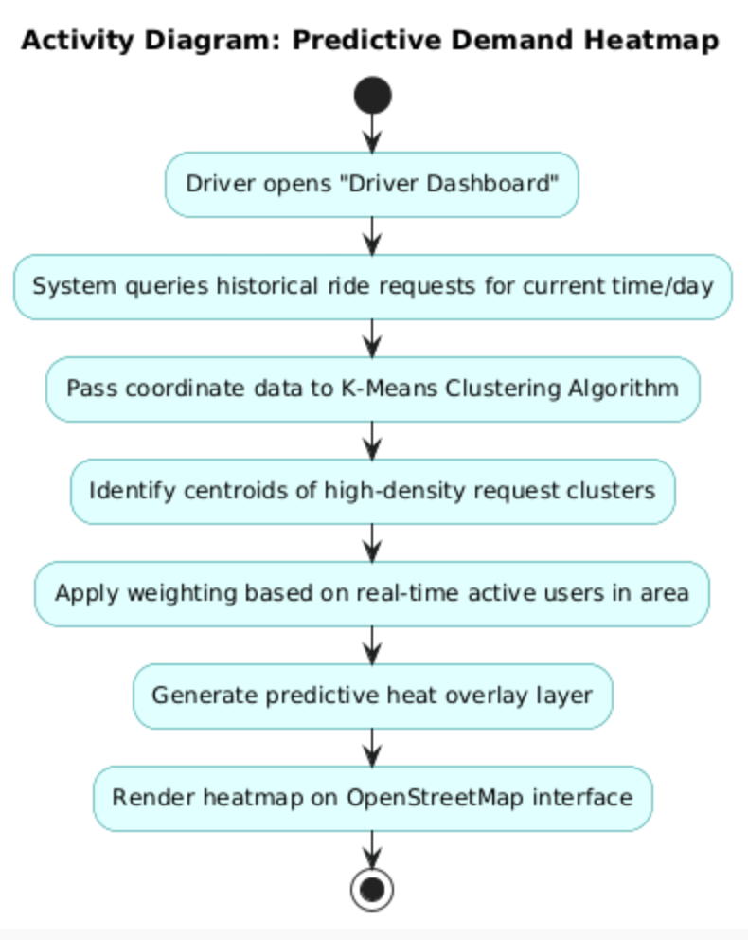

3. NLP-Driven Chat Moderation
AI Justification: Uses Natural Language Processing (NLP) sentiment analysis to scan in-app messages in real-time, preventing harassment or inappropriate behavior before it reaches the user.
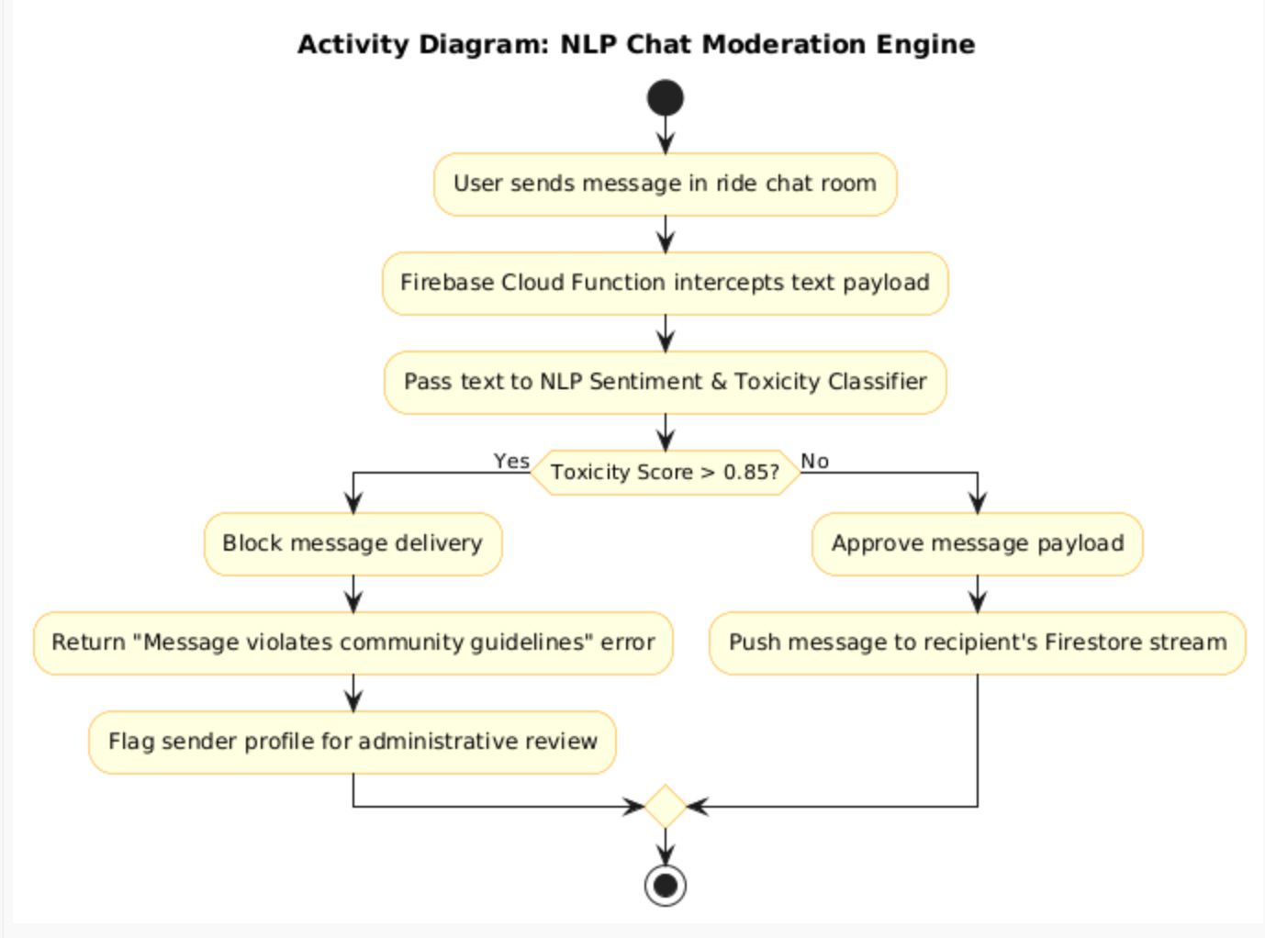

4. Smart ETA Predictor (Traffic Machine Learning)
AI Justification: Enhances the standard OSRM time estimate by applying a regression model trained on historical traffic delays for specific times of day in Pakistani cities.

